MINI-ASSIGNMENT
Name-Farhan Alam Roll no-12340740
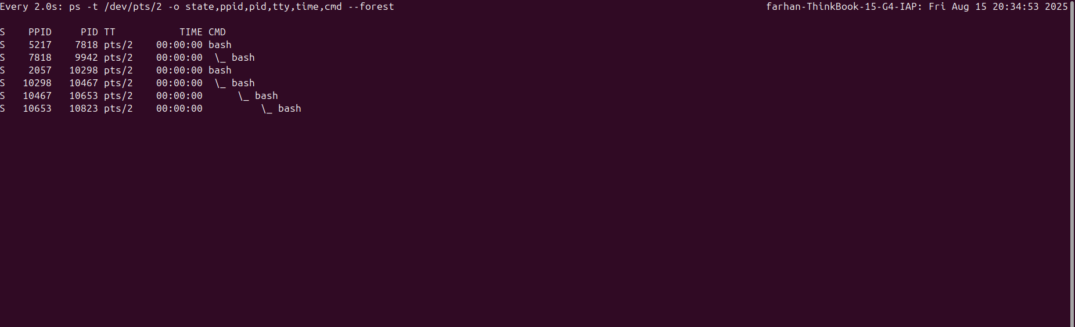
As the parent is killed so its process becomes an independent process having no parent and the process which was parent of the killed process has no child now . But if we kill the very first process that is the terminal the terminal gets closed prompting an error in the other terminal where we watch the process.

